FLORAL ART SHOW GUIDE HANDBOOK ORDERING FORM

THE ROYAL HORTICULTURAL SOCIETY OF NSW Inc.
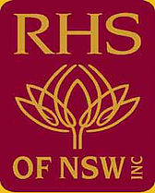
FLORAL ART SHOW GUIDE HANDBOOK

COST $30 including colour wheel and postage

$22 if you purchase at one of our meetings

ORDER FORM

Name ……………………………………………………………..

Address …………………………………………………………

…………………………………………………………Post Code ………………….

Cheque to be made payable to the R.H.S of NSW Inc

Payment by credit card VISA or MASTERCARD only

Card number ……………. …………… …………… …………..

Expiry date ……/…….

Name as it appears on card …………………………………………………..……..…

Signature ………………………………………………………………………. Amount …………………………………

Email address for receipt notification ………………………………………………

Form and payment can be posted to P.O. Box 6070, Baulkham Hills B.C. 2153 or for credit card payment emailed to ….. jackietweedie@hotmail.com

